**Exercise 1**

**Problem 1**

Database – A collection of related data

DBMS – A computerized system that enables users to create and maintain a database.

Self-describing nature – The database does not only contain the database itself, but also a complete definition or description of the database structure and constraints.

Program-data independence – The structure of data files is stored separately from the access programs in the DBMS catalog. A consequence of this is that it is possible to change the data structure of a file does not necessarily require changing all programs that access the file.

Multi-user support – Several programs or users can access the database simultaneously. This requires concurrency protection s.t. no read/write operations can collide and corrupt the data.

**Problem 2**

1. 1) An entity describes an actual physical world item or object, whilst an entity class is a gathering of items or objects with the same structure or behavior.
2. A relation describes the cohersion between two or more entities, whilst a relation class is the quantity of equal relations between to entity classes.
3. Since the attributes describe the entity, it wouldn’t exist without atleast one attribute.
4. 1) True – It is a key attribute

2)True – (0,n) relation means as many as you want

3)False – (1,n) relation, means atleast 1

4)True – there is no roof to n tacos

5)False – Order has a pickUpTime, so no

6)True – Since the lower limits of orders pr customer is 0.

7)False – The relation between vegetable and taco has a weight, not the vegetable itself. Instances of taco can have different weights.

8)True – Since the relation contains a job title, and it has (1,n) relation, a worker can have different titles.

9)False – Nothing indicates this in the model

10)False – No?

**Problem 3**

1. We use weak entity types when an entity class lacks a natural key. What I mean with this is that the screen room wouldn’t exist without the cinema.

An identifying entity type is the entity that determines the weak entity type’s existence through a relation.

The identifying relationship is that the screenroom is at the cinema.

The partial key is found in weak entities, and it is like the key attribute of an entity.

1. If one changes the cardinality of ScreenRoom to (0,1), one says that a ScreenRoom does not necessarily belong to a cinema. Thus it can exist without the cinema, and can not be modelled as a weak entity. If one changes to (1,n), one says that a ScreenRoom must belong to atleast 1 cinema, but it can also belong to several. Thus it can still be modelled as a weak entity type.
2. 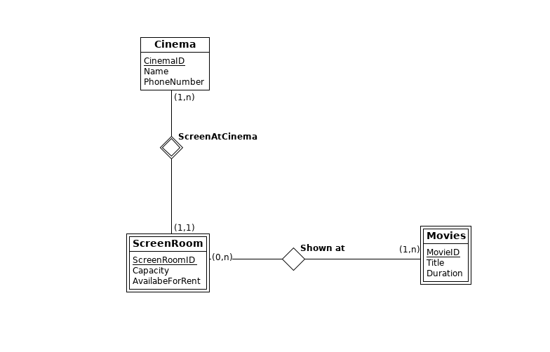Look Picture
3. Picture

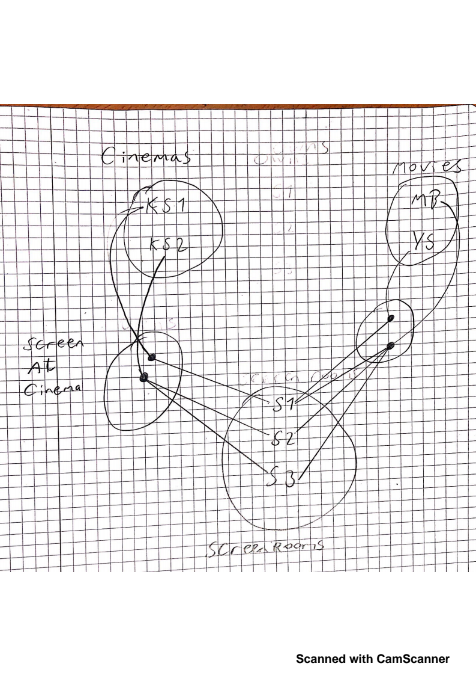

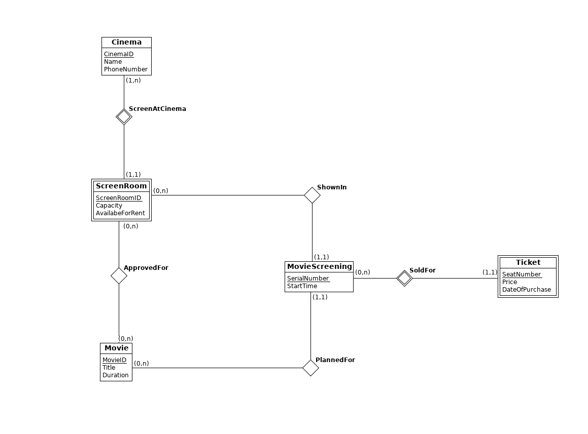e)

**Problem 4**

